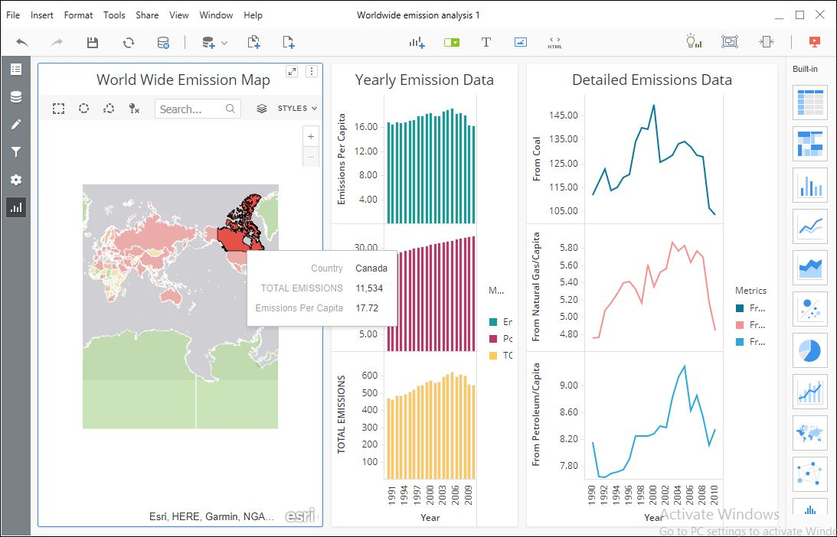

1. Total emission in Canada is 11534
2. General trend in emission is increasing
3. A possible cause for decrease in emission in 2009 could be a sudden drive by environmentalist to create awareness among people and government

